Password door lock
system

Aim:
To design and implement a Password-Protected Door Lock System using a keypad and LED indicators that ensures secure access control by allowing entry only when the correct password is entered, and provides visual feedback through LEDs for correct and incorrect password attempts.

Tool required: Modelsim software and Quartus software
Password-Protected Door Lock System Using Keypad and LED Indicators
Introduction:
A password-protected door lock system is a security-based project designed to control access to a door or a restricted area. Instead of using a physical key, this system uses a numeric password entered through a keypad. The system checks whether the entered password matches the pre-stored password. If it matches, the door unlocks (indicated by an LED or relay), otherwise access is denied, and a red LED glows to indicate an incorrect password.
Objective:
The main objective of this project is to provide a secure, cost-effective, and easy-to-use door locking system that can be implemented in homes, offices, and laboratories without the need for physical keys.

Components Used:
- Keypad (4x4 or 3x4): Used to enter the password.
- Microcontroller / FPGA / Arduino (depending on your platform): Processes the entered password and compares it with the stored one.
- LED Indicators:
  - Green LED – indicates access granted (door unlocked).
  - Red LED – indicates wrong password (access denied).
- Buzzer (optional): Gives an audible alert for incorrect password attempts.
- Power Supply: Provides the necessary operating voltage to the circuit.

Working Principle:
- The system starts in a locked state.
- The user is prompted to enter a password using the keypad.
- The microcontroller (or logic circuit) reads the input digits one by one.
- Once the full password is entered, it is compared with a pre-defined password stored in memory.
  - If the entered password matches, the green LED turns ON, and the door is unlocked (simulated using an LED or relay).
  - If the password does not match, the red LED turns ON, and the system remains locked.
Applications:
- Home and office door security systems
- Safe lockers or cabinets
- Lab access control systems
- Industrial control panels requiring restricted access

Advantages:
- No physical keys required – prevents key loss or duplication.
- Easily reprogrammable password – improves flexibility.
- Low cost and simple design.
- Visual feedback through LEDs for user clarity.

Working FPGA implementation:


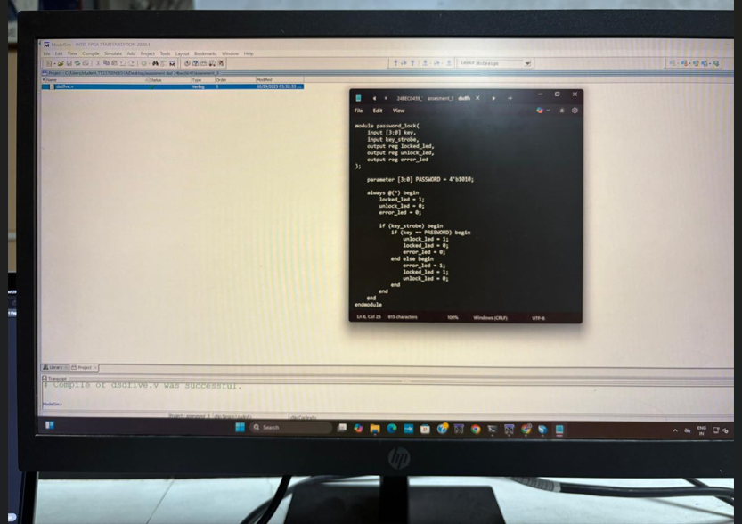
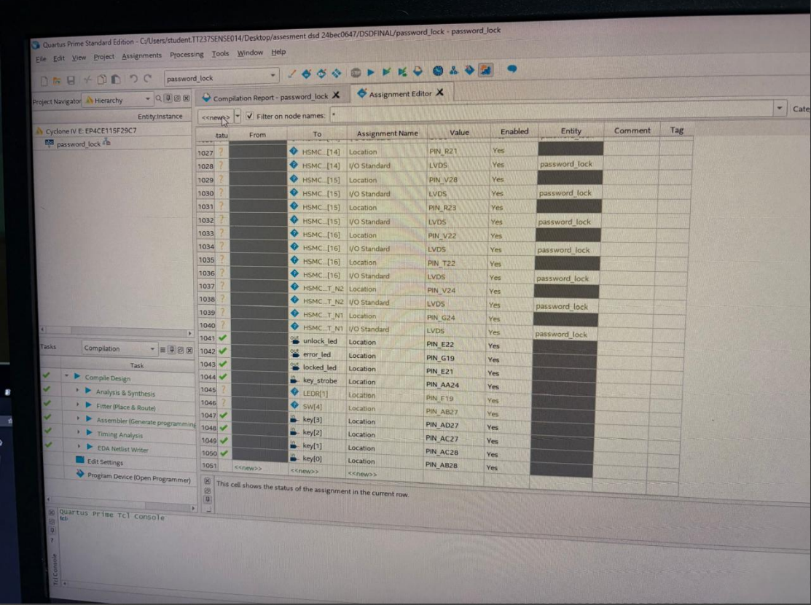

Verilog code:

module password_lock (
input [3:0] key,
input key_strobe,
output reg locked_led,
output reg unlock_led,
output reg error_led
);

parameter [3:0] PASSWORD = 4'b1010;

always @(*) begin
// Default state
locked_led = 1;
unlock_led = 0;
error_led = 0;

if (key_strobe) begin
if (key == PASSWORD) begin
unlock_led = 1;
locked_led = 0;
error_led = 0;
end
else begin
error_led = 1;
locked_led = 1;
unlock_led = 0;
end
end
end

endmodule

